1. Main interface

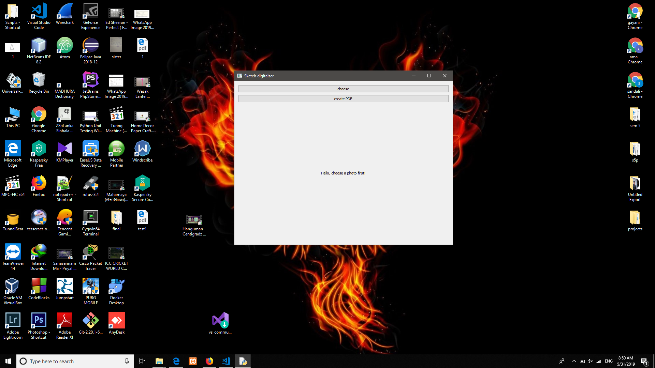

1. When click “choose” button

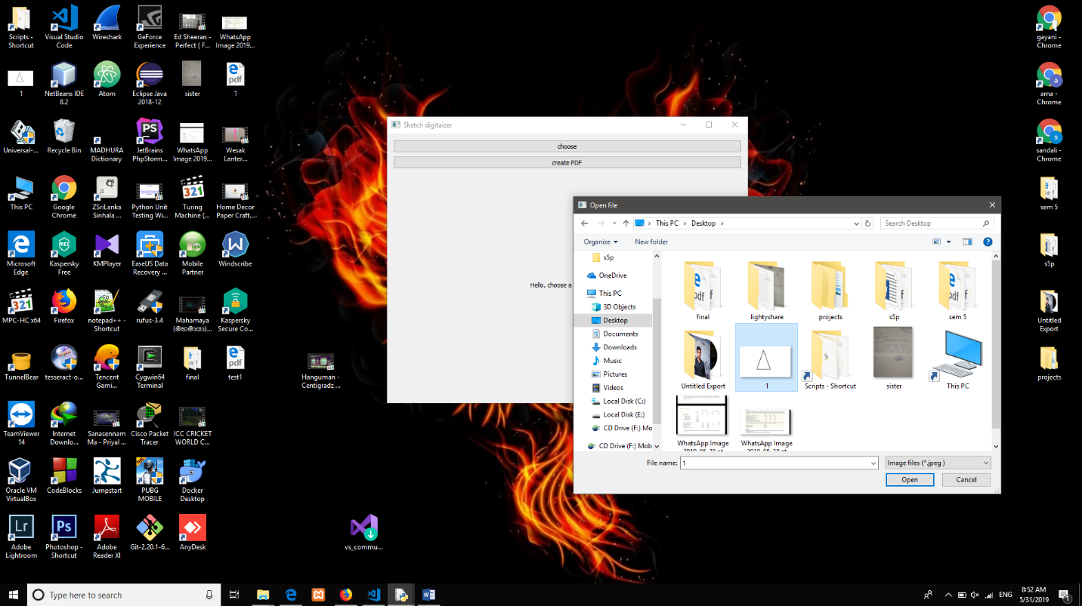

1. When image is selected and identified by

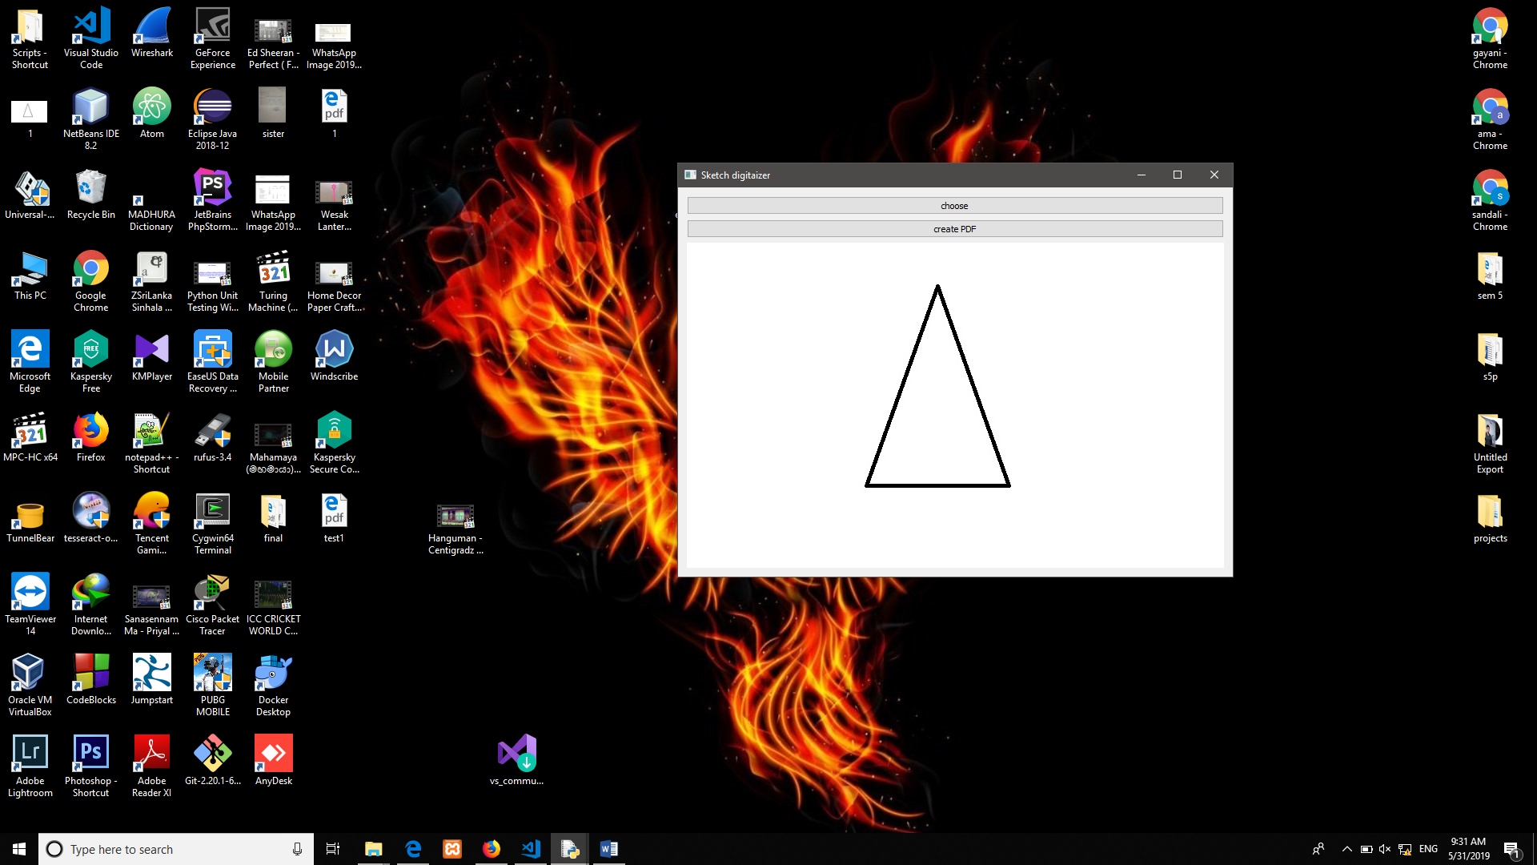

1. When “create PDF” button clicked.

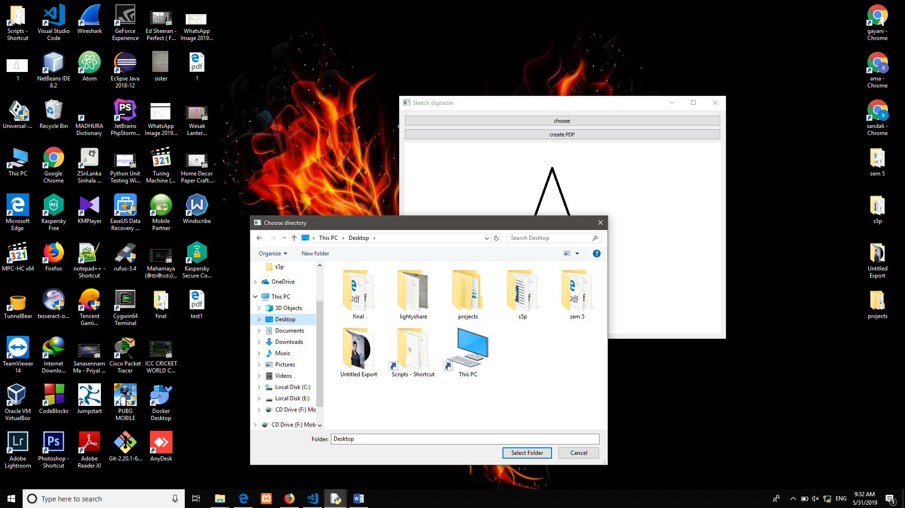

1. When PDF generated successfully

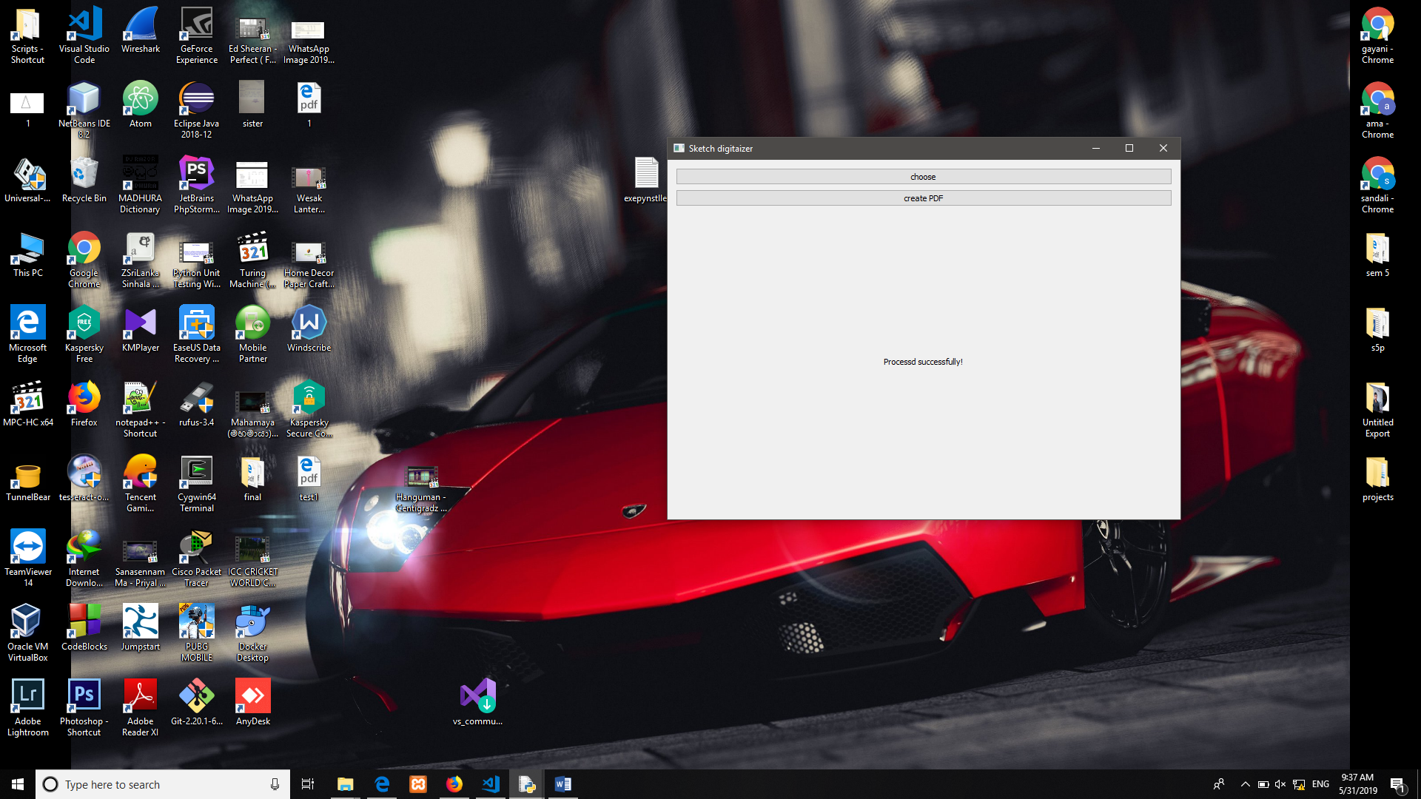

1. When there is no image selected and clicked “create PDF” button.

